**Model outputs**

**Larval fish and wind mechanism**

Model assumptions = good

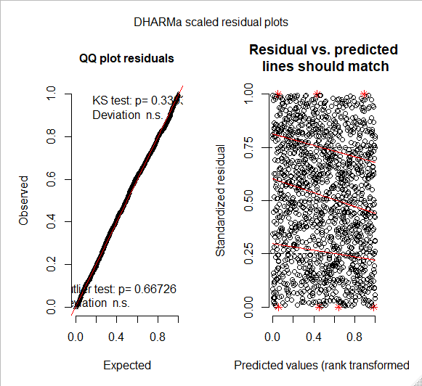

Summary:

Family: tweedie ( log )

Formula: Coastal_Normalised_Abund ~ SE_Winds.standardised * NE_Winds.standardised * dists_km + (1 | Project_ID)

Data: fish_data

AIC BIC logLik deviance df.resid

-5467.4 -5409.6 2744.7 -5489.4 1408

Random effects:

Conditional model:

Groups Name Variance Std.Dev.

Project_ID (Intercept) 0.6372 0.7983

Number of obs: 1419, groups: Project_ID, 6

Overdispersion parameter for tweedie family (): 0.452

Conditional model:

Estimate Std. Error z value Pr(>|z|)

(Intercept) -5.329864 0.370986 -14.367 < 2e-16 ***

SE_Winds.standardised 0.695273 0.090699 7.666 1.78e-14 ***

NE_Winds.standardised -0.349896 0.087952 -3.978 6.94e-05 ***

dists_km -0.017969 0.008446 -2.127 0.0334 *

SE_Winds.standardised:NE_Winds.standardised -0.900791 0.104537 -8.617 < 2e-16 ***

SE_Winds.standardised:dists_km -0.019864 0.007243 -2.742 0.0061 **

NE_Winds.standardised:dists_km 0.011019 0.007988 1.379 0.1678

SE_Winds.standardised:NE_Winds.standardised:dists_km 0.049614 0.009387 5.285 1.26e-07 ***

---

Signif. codes: 0 ‘***’ 0.001 ‘**’ 0.01 ‘*’ 0.05 ‘.’ 0.1 ‘ ’ 1

Anova:

> Anova(fit3,type="II",test="Chisq")

Analysis of Deviance Table (Type II Wald chisquare tests)

Response: Coastal_Normalised_Abund

Chisq Df Pr(>Chisq)

SE_Winds.standardised 58.2349 1 2.326e-14 ***

NE_Winds.standardised 5.8133 1 0.01591 *

dists_km 5.5989 1 0.01797 *

SE_Winds.standardised:NE_Winds.standardised 49.9601 1 1.569e-12 ***

SE_Winds.standardised:dists_km 4.4094 1 0.03574 *

NE_Winds.standardised:dists_km 1.6084 1 0.20471

SE_Winds.standardised:NE_Winds.standardised:dists_km 27.9329 1 1.256e-07 ***

---

Signif. codes: 0 ‘***’ 0.001 ‘**’ 0.01 ‘*’ 0.05 ‘.’ 0.1 ‘ ’ 1

SE Historical Wind Changes Model

Model assumptions (OK, not perfect)

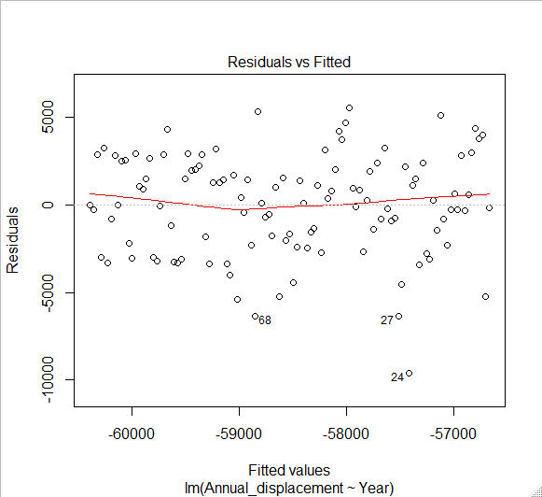

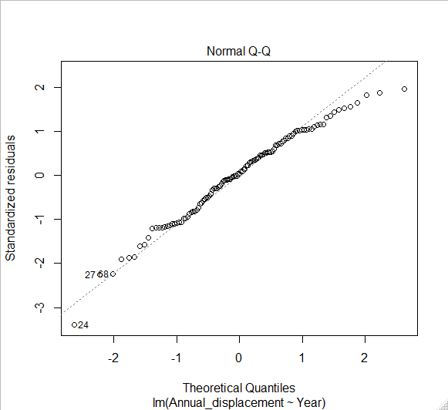

Summary:

> summary(fit1)

Call:

lm(formula = Annual_displacement ~ Year, data = dat2)

Residuals:

Min 1Q Median 3Q Max

-9597 -2126 113 2114 5546

Coefficients:

Estimate Std. Error t value Pr(>|t|)

(Intercept) 5246.085 15655.442 0.335 0.738

Year -32.587 7.999 -4.074 8.61e-05 ***

---

Signif. codes: 0 ‘***’ 0.001 ‘**’ 0.01 ‘*’ 0.05 ‘.’ 0.1 ‘ ’ 1

Residual standard error: 2847 on 113 degrees of freedom

Multiple R-squared: 0.1281, Adjusted R-squared: 0.1204

F-statistic: 16.6 on 1 and 113 DF, p-value: 8.611e-05

ANOVA:

> anova(fit1)

Analysis of Variance Table

Response: Annual_displacement

Df Sum Sq Mean Sq F value Pr(>F)

Year 1 134575198 134575198 16.598 8.611e-05 ***

Residuals 113 916182357 8107808

---

Signif. codes: 0 ‘***’ 0.001 ‘**’ 0.01 ‘*’ 0.05 ‘.’ 0.1 ‘ ’ 1

NE Historical Winds

Assumptions (OK)

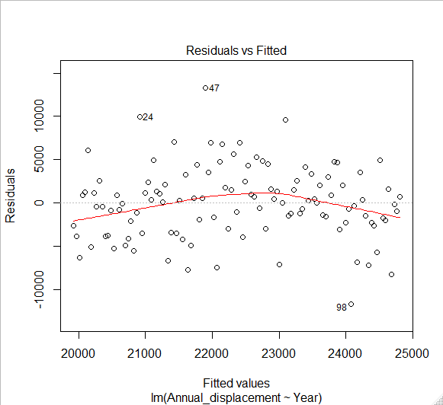

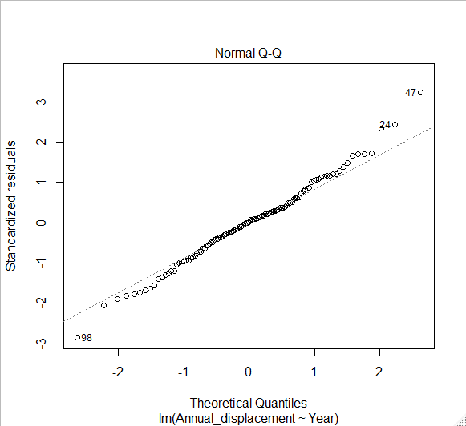

Summary:

> summary(fit2)

Call:

lm(formula = Annual_displacement ~ Year, data = dat2_NE)

Residuals:

Min 1Q Median 3Q Max

-11680.0 -2447.9 62.5 2266.3 13285.6

Coefficients:

Estimate Std. Error t value Pr(>|t|)

(Intercept) -61437.24 22755.61 -2.700 0.008003 **

Year 42.82 11.63 3.683 0.000355 ***

---

Signif. codes: 0 ‘***’ 0.001 ‘**’ 0.01 ‘*’ 0.05 ‘.’ 0.1 ‘ ’ 1

Residual standard error: 4139 on 113 degrees of freedom

Multiple R-squared: 0.1072, Adjusted R-squared: 0.09929

F-statistic: 13.57 on 1 and 113 DF, p-value: 0.0003548

ANOVA:

> anova(fit2)

Analysis of Variance Table

Response: Annual_displacement

Df Sum Sq Mean Sq F value Pr(>F)

Year 1 232398244 232398244 13.567 0.0003548 ***

Residuals 113 1935656911 17129707

---

Signif. codes: 0 ‘***’ 0.001 ‘**’ 0.01 ‘*’ 0.05 ‘.’ 0.1 ‘ ’ 1

Commercial Scale:

Bream:

Assumptions (Not great but acceptable):

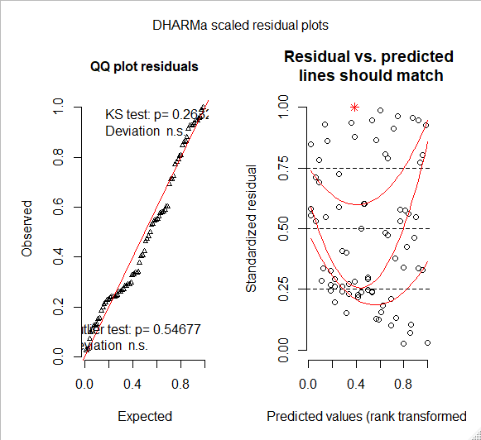

Summary:

> summary(m1)

Linear mixed model fit by REML. t-tests use Satterthwaite's method ['lmerModLmerTest']

Formula: CPUE.standardised ~ X135_degree_winds.standardised * X45_degree_winds.standardised +

Estuary_Type + Drought_Months + (1 | Estuary)

Data: bream

REML criterion at convergence: 205.8

Scaled residuals:

Min 1Q Median 3Q Max

-1.9048 -0.6502 -0.1517 0.6195 2.5555

Random effects:

Groups Name Variance Std.Dev.

Estuary (Intercept) 1.673e-32 1.294e-16

Residual 6.713e-01 8.193e-01

Number of obs: 80, groups: Estuary, 8

Fixed effects:

Estimate Std. Error df t value Pr(>|t|)

(Intercept) -0.54388 0.20400 73.00000 -2.666 0.00944 **

X135_degree_winds.standardised 0.33522 0.13847 73.00000 2.421 0.01797 *

X45_degree_winds.standardised 0.12021 0.12350 73.00000 0.973 0.33359

Estuary_TypeBarrier River 0.01142 0.21157 73.00000 0.054 0.95709

Estuary_TypeDrowned River Valley 0.02570 0.23657 73.00000 0.109 0.91379

Drought_Months 0.17132 0.03128 73.00000 5.477 5.83e-07 ***

X135_degree_winds.standardised:X45_degree_winds.standardised 0.04548 0.16615 73.00000 0.274 0.78508

---

Signif. codes: 0 ‘***’ 0.001 ‘**’ 0.01 ‘*’ 0.05 ‘.’ 0.1 ‘ ’ 1

Correlation of Fixed Effects:

(Intr) X135_d_. X45__. Es_TBR E_TDRV Drgh_M

X135_dgr_w. 0.028

X45_dgr_wn. 0.231 0.524

Estry_TypBR -0.524 0.003 -0.002

Estry_TyDRV -0.475 0.006 -0.003 0.447

Drght_Mnths -0.564 0.286 -0.170 0.010 0.020

X135__.:X45 0.460 0.449 0.378 -0.001 -0.003 -0.150

convergence code: 0

boundary (singular) fit: see ?isSingular

Anova:

> anova(m1) # bream increase with SE Winds

Type III Analysis of Variance Table with Satterthwaite's method

Sum Sq Mean Sq NumDF DenDF F value Pr(>F)

X135_degree_winds.standardised 3.9344 3.9344 1 73 5.8607 0.01797 *

X45_degree_winds.standardised 0.6360 0.6360 1 73 0.9474 0.33359

Estuary_Type 0.0079 0.0040 2 73 0.0059 0.99410

Drought_Months 20.1413 20.1413 1 73 30.0020 5.834e-07 ***

X135_degree_winds.standardised:X45_degree_winds.standardised 0.0503 0.0503 1 73 0.0749 0.78508

---

Signif. codes: 0 ‘***’ 0.001 ‘**’ 0.01 ‘*’ 0.05 ‘.’ 0.1 ‘ ’ 1

Effects plots (may be dodgy with Random effects but should be OK)

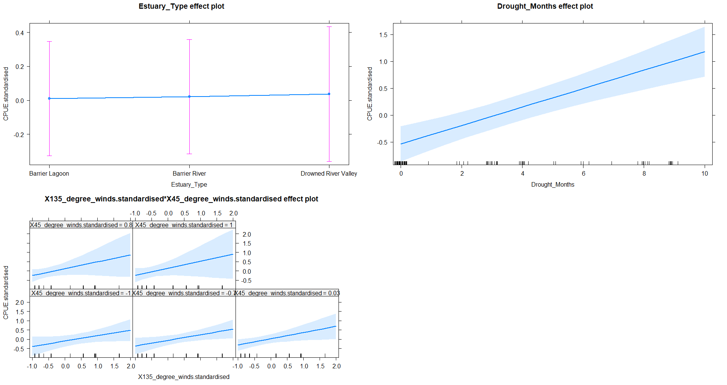

Mullet:

Assumptions (OK):

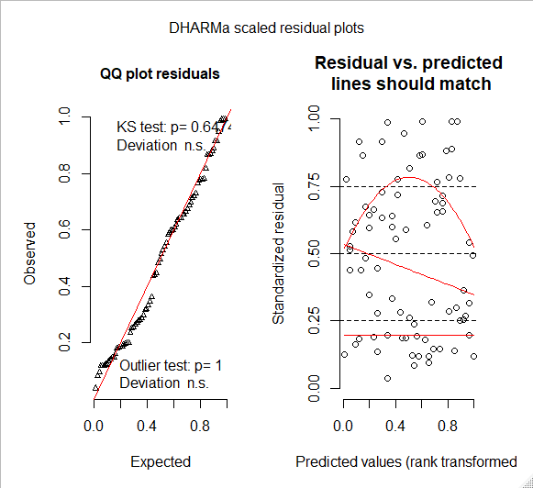

Summary:

> summary(m2)

Linear mixed model fit by REML. t-tests use Satterthwaite's method ['lmerModLmerTest']

Formula: CPUE.standardised ~ X135_degree_winds.standardised * X45_degree_winds.standardised +

Estuary_Type * Drought_Months + (1 | Estuary)

Data: mullet

REML criterion at convergence: 226.9

Scaled residuals:

Min 1Q Median 3Q Max

-1.59312 -0.80461 0.03936 0.52569 2.66157

Random effects:

Groups Name Variance Std.Dev.

Estuary (Intercept) 4.274e-32 2.067e-16

Residual 8.242e-01 9.079e-01

Number of obs: 80, groups: Estuary, 8

Fixed effects:

Estimate Std. Error df t value Pr(>|t|)

(Intercept) -0.29516 0.24419 71.00000 -1.209 0.23077

X135_degree_winds.standardised -0.14658 0.10954 71.00000 -1.338 0.18512

X45_degree_winds.standardised 0.14959 0.12431 71.00000 1.203 0.23281

Estuary_TypeBarrier River 0.69005 0.32251 71.00000 2.140 0.03582 *

Estuary_TypeDrowned River Valley 0.56769 0.36652 71.00000 1.549 0.12586

Drought_Months 0.08561 0.05470 71.00000 1.565 0.12201

X135_degree_winds.standardised:X45_degree_winds.standardised 0.10276 0.13077 71.00000 0.786 0.43459

Estuary_TypeBarrier River:Drought_Months -0.21165 0.06769 71.00000 -3.127 0.00256 **

Estuary_TypeDrowned River Valley:Drought_Months -0.17614 0.07976 71.00000 -2.208 0.03045 *

---

Signif. codes: 0 ‘***’ 0.001 ‘**’ 0.01 ‘*’ 0.05 ‘.’ 0.1 ‘ ’ 1

Correlation of Fixed Effects:

(Intr) X135_d_. X45__. Es_TBR Es_TDRV Drgh_M X135__.: E_TBR:

X135_dgr_w. 0.042

X45_dgr_wn. 0.249 -0.070

Estry_TypBR -0.718 0.019 -0.043

Estry_TyDRV -0.625 0.001 -0.009 0.472

Drght_Mnths -0.731 -0.067 -0.330 0.501 0.431

X135__.:X45 0.021 0.113 -0.064 -0.026 -0.011 -0.118

Est_TBR:D_M 0.531 -0.028 0.058 -0.687 -0.345 -0.722 0.036

Es_TDRV:D_M 0.439 -0.003 0.002 -0.333 -0.699 -0.596 0.013 0.480

convergence code: 0

boundary (singular) fit: see ?isSingular

ANOVA:

> anova(m2) # No effects from mullet

Type III Analysis of Variance Table with Satterthwaite's method

Sum Sq Mean Sq NumDF DenDF F value Pr(>F)

X135_degree_winds.standardised 1.4759 1.4759 1 71 1.7906 0.185123

X45_degree_winds.standardised 1.1937 1.1937 1 71 1.4482 0.232807

Estuary_Type 4.0820 2.0410 2 71 2.4762 0.091292 .

Drought_Months 1.2370 1.2370 1 71 1.5008 0.224597

X135_degree_winds.standardised:X45_degree_winds.standardised 0.5090 0.5090 1 71 0.6175 0.434588

Estuary_Type:Drought_Months 8.5937 4.2968 2 71 5.2131 0.007719 **

---

Signif. codes: 0 ‘***’ 0.001 ‘**’ 0.01 ‘*’ 0.05 ‘.’ 0.1 ‘ ’ 1

Effects plot:

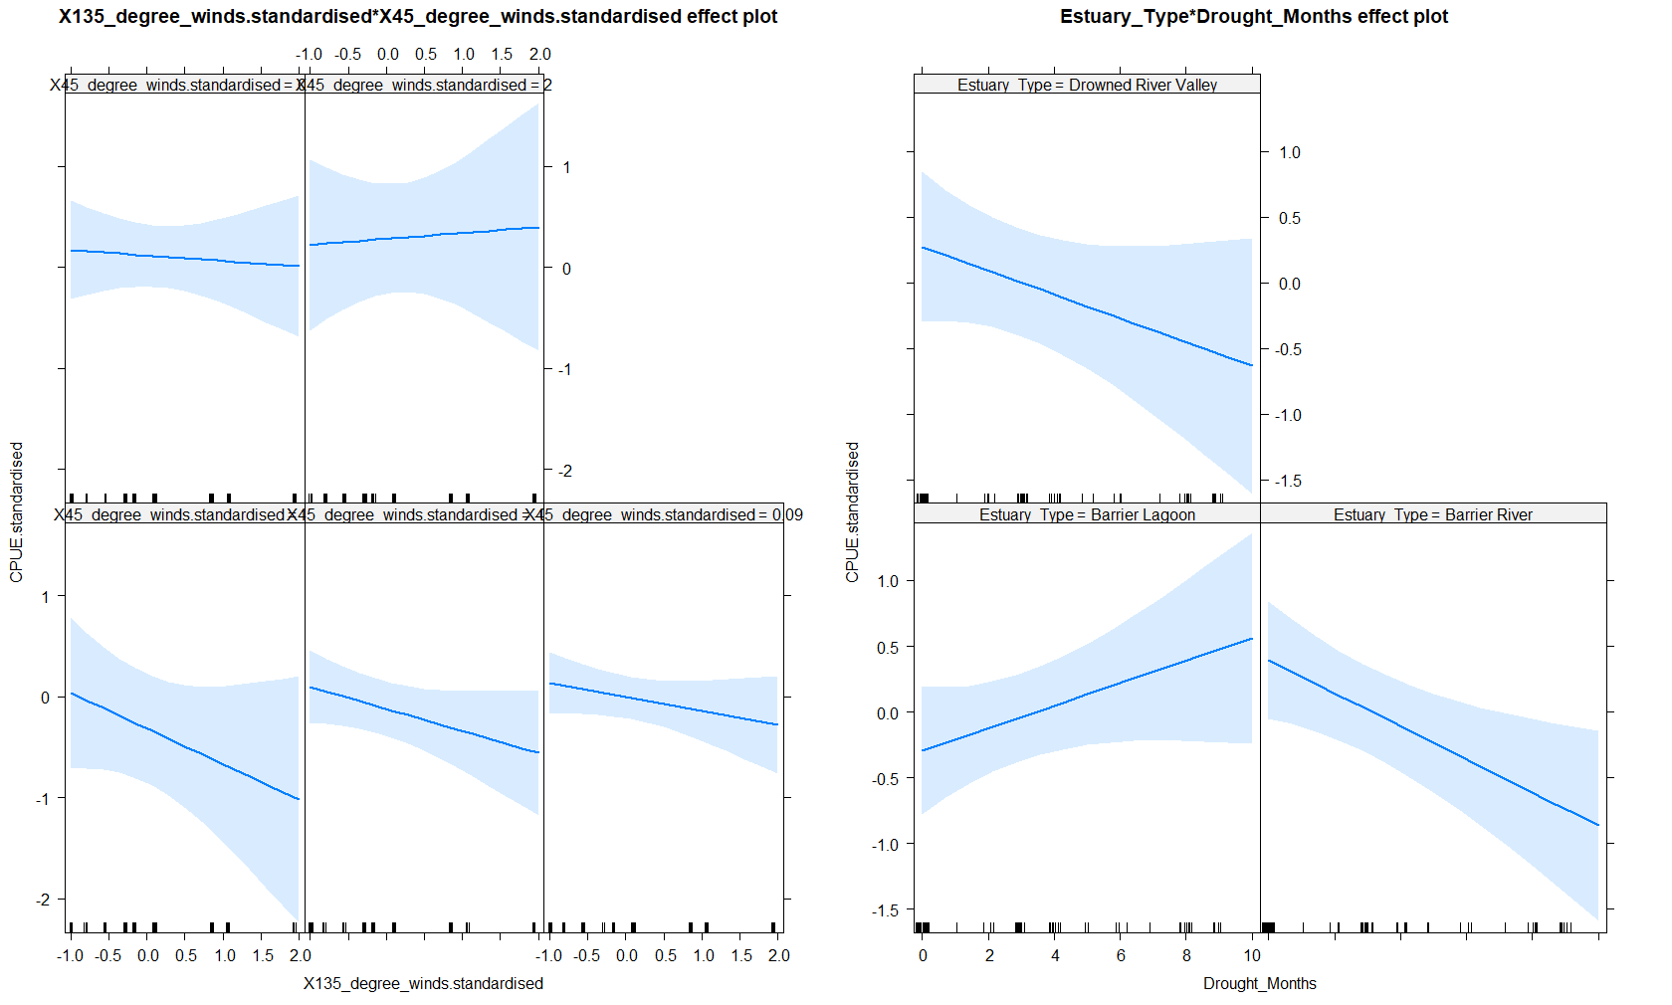

Luderick:

Assumptions (OK)

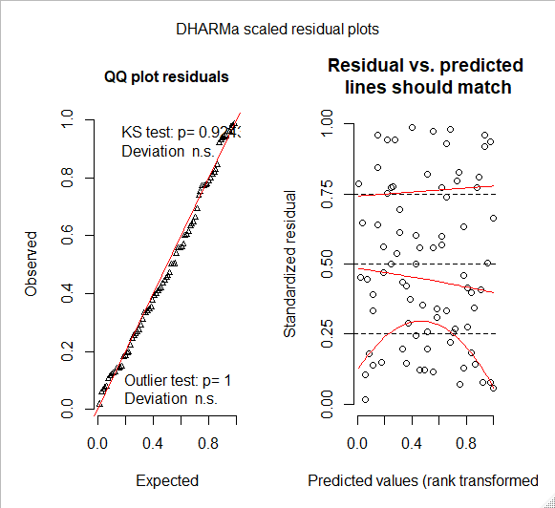

Summary:

> summary(m4)

Linear mixed model fit by REML. t-tests use Satterthwaite's method ['lmerModLmerTest']

Formula: CPUE.standardised ~ X135_degree_winds.standardised * X45_degree_winds.standardised +

Estuary_Type + Drought_Months + (1 | Estuary)

Data: luderick

REML criterion at convergence: 231.6

Scaled residuals:

Min 1Q Median 3Q Max

-1.9483 -0.7138 -0.1150 0.6341 2.4794

Random effects:

Groups Name Variance Std.Dev.

Estuary (Intercept) 2.384e-32 1.544e-16

Residual 9.449e-01 9.721e-01

Number of obs: 80, groups: Estuary, 8

Fixed effects:

Estimate Std. Error df t value Pr(>|t|)

(Intercept) -0.040297 0.207575 73.000000 -0.194 0.847

X135_degree_winds.standardised -0.041735 0.144221 73.000000 -0.289 0.773

X45_degree_winds.standardised 0.185954 0.141477 73.000000 1.314 0.193

Estuary_TypeBarrier River 0.001176 0.250999 73.000000 0.005 0.996

Estuary_TypeDrowned River Valley 0.002646 0.280673 73.000000 0.009 0.993

Drought_Months 0.017643 0.039422 73.000000 0.448 0.656

X135_degree_winds.standardised:X45_degree_winds.standardised 0.036444 0.148346 73.000000 0.246 0.807

Correlation of Fixed Effects:

(Intr) X135_d_. X45__. Es_TBR E_TDRV Drgh_M

X135_dgr_w. 0.137

X45_dgr_wn. 0.072 0.500

Estry_TypBR -0.609 -0.003 0.000

Estry_TyDRV -0.550 -0.007 0.000 0.447

Drght_Mnths -0.429 -0.317 0.005 0.010 0.021

X135__.:X45 0.000 -0.176 0.214 0.006 0.012 0.561

convergence code: 0

boundary (singular) fit: see ?isSingular

ANOVA:

> anova(m4)

Type III Analysis of Variance Table with Satterthwaite's method

Sum Sq Mean Sq NumDF DenDF F value Pr(>F)

X135_degree_winds.standardised 0.07913 0.07913 1 73 0.0837 0.7731

X45_degree_winds.standardised 1.63240 1.63240 1 73 1.7276 0.1928

Estuary_Type 0.00008 0.00004 2 73 0.0000 1.0000

Drought_Months 0.18925 0.18925 1 73 0.2003 0.6558

X135_degree_winds.standardised:X45_degree_winds.standardised 0.05703 0.05703 1 73 0.0604 0.8066

Effects Plot:

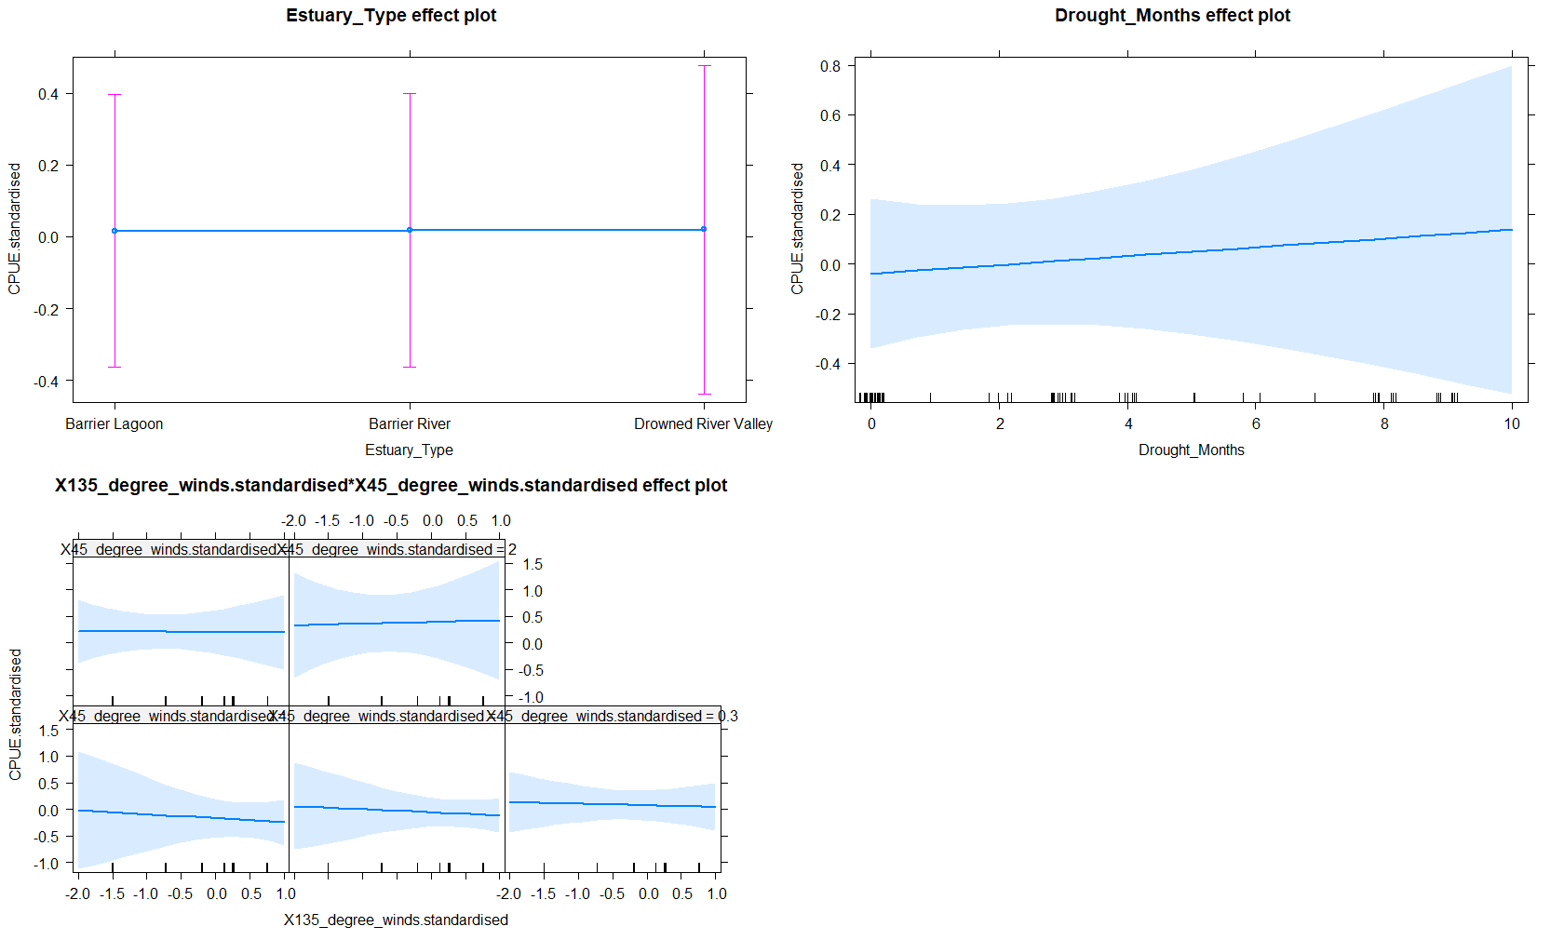

Flathead:

Assumptions (OK):

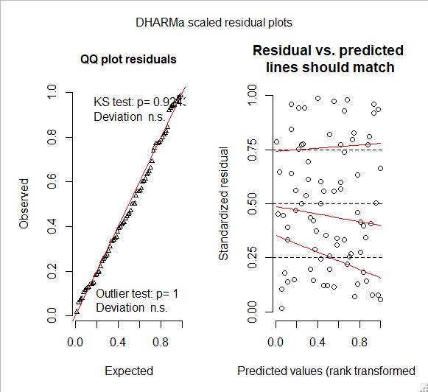

Summary:

> summary(m3)

Linear mixed model fit by REML. t-tests use Satterthwaite's method ['lmerModLmerTest']

Formula: CPUE.standardised ~ X135_degree_winds.standardised * X45_degree_winds.standardised +

Estuary_Type * Drought_Months + (1 | Estuary)

Data: flathead

REML criterion at convergence: 226.4

Scaled residuals:

Min 1Q Median 3Q Max

-1.7599 -0.6205 -0.2184 0.4922 2.6486

Random effects:

Groups Name Variance Std.Dev.

Estuary (Intercept) 4.518e-32 2.126e-16

Residual 8.330e-01 9.127e-01

Number of obs: 80, groups: Estuary, 8

Fixed effects:

Estimate Std. Error df t value Pr(>|t|)

(Intercept) -0.025399 0.256886 71.000000 -0.099 0.9215

X135_degree_winds.standardised -0.013991 0.158610 71.000000 -0.088 0.9300

X45_degree_winds.standardised 0.141084 0.149715 71.000000 0.942 0.3492

Estuary_TypeBarrier River 0.551074 0.324249 71.000000 1.700 0.0936 .

Estuary_TypeDrowned River Valley -0.102247 0.368454 71.000000 -0.278 0.7822

Drought_Months 0.003898 0.053711 71.000000 0.073 0.9424

X135_degree_winds.standardised:X45_degree_winds.standardised -0.022804 0.205058 71.000000 -0.111 0.9118

Estuary_TypeBarrier River:Drought_Months -0.170355 0.068071 71.000000 -2.503 0.0146 *

Estuary_TypeDrowned River Valley:Drought_Months 0.032645 0.080211 71.000000 0.407 0.6852

---

Signif. codes: 0 ‘***’ 0.001 ‘**’ 0.01 ‘*’ 0.05 ‘.’ 0.1 ‘ ’ 1

Correlation of Fixed Effects:

(Intr) X135_d_. X45__. Es_TBR Es_TDRV Drgh_M X135__.: E_TBR:

X135_dgr_w. 0.260

X45_dgr_wn. 0.223 0.642

Estry_TypBR -0.678 0.009 -0.037

Estry_TyDRV -0.599 -0.006 0.002 0.470

Drght_Mnths -0.625 -0.107 -0.246 0.508 0.433

X135__.:X45 0.337 0.425 0.121 0.013 -0.014 0.148

Est_TBR:D_M 0.497 -0.015 0.051 -0.687 -0.344 -0.731 -0.016

Es_TDRV:D_M 0.425 0.005 -0.011 -0.331 -0.699 -0.600 0.026 0.478

convergence code: 0

boundary (singular) fit: see ?isSingular

ANOVA:

> anova(m3) # No effects for Flathead

Type III Analysis of Variance Table with Satterthwaite's method

Sum Sq Mean Sq NumDF DenDF F value Pr(>F)

X135_degree_winds.standardised 0.0065 0.0065 1 71 0.0078 0.92996

X45_degree_winds.standardised 0.7397 0.7397 1 71 0.8880 0.34921

Estuary_Type 3.6470 1.8235 2 71 2.1892 0.11951

Drought_Months 1.2365 1.2365 1 71 1.4845 0.22710

X135_degree_winds.standardised:X45_degree_winds.standardised 0.0103 0.0103 1 71 0.0124 0.91177

Estuary_Type:Drought_Months 7.9906 3.9953 2 71 4.7966 0.01112 *

---

Signif. codes: 0 ‘***’ 0.001 ‘**’ 0.01 ‘*’ 0.05 ‘.’ 0.1 ‘ ’ 1

Effects Plot:

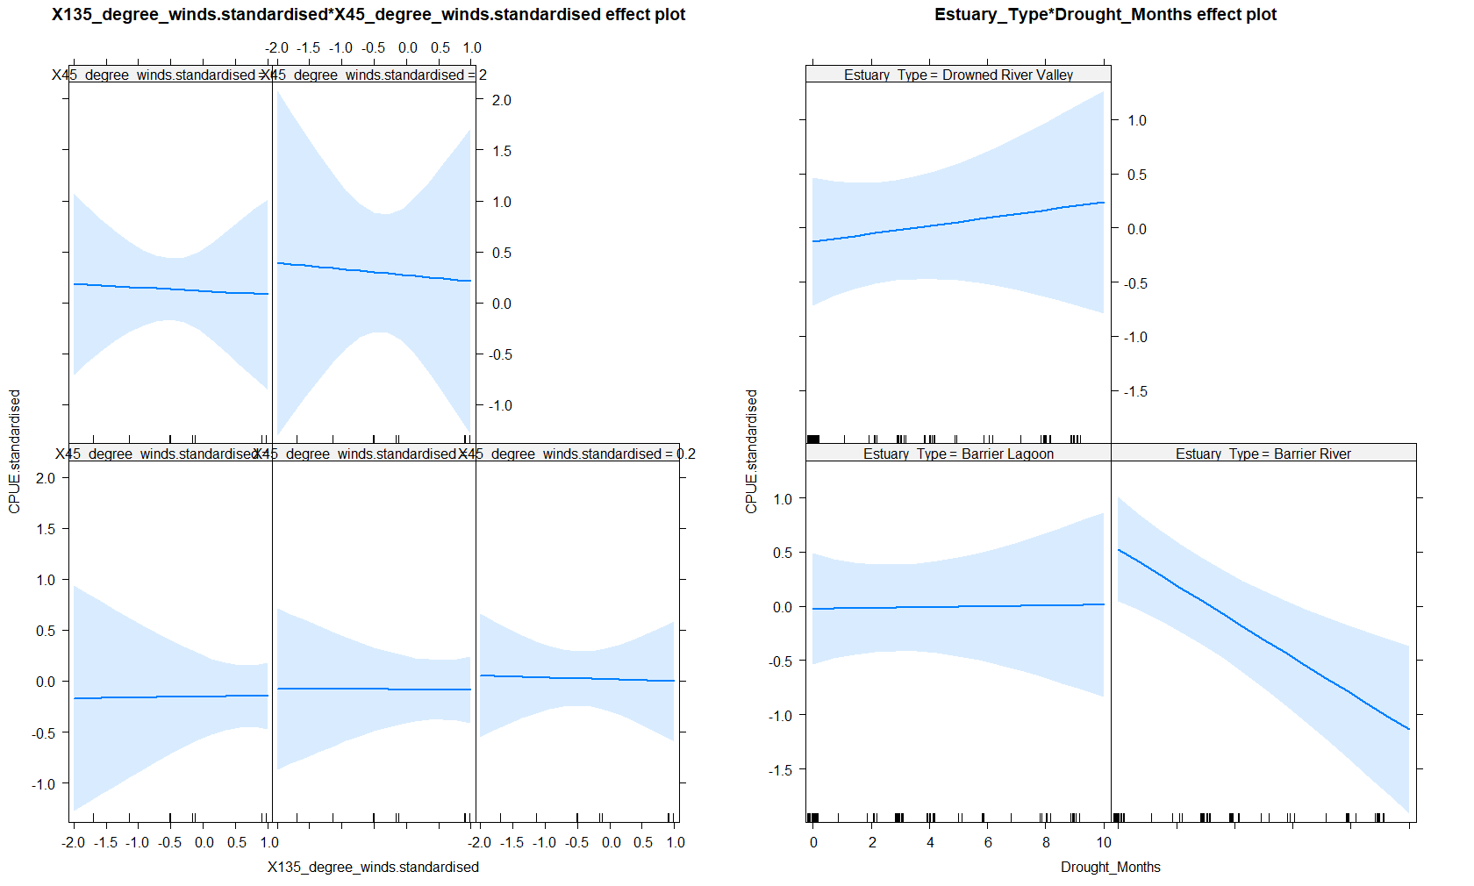

Whiting:

Assumptions (OK):

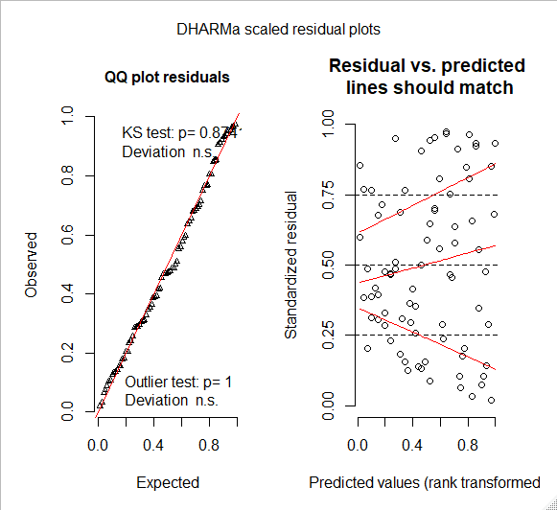

Summary:

> summary(m5)

Linear mixed model fit by REML. t-tests use Satterthwaite's method ['lmerModLmerTest']

Formula: CPUE.standardised ~ X135_degree_winds.standardised * X45_degree_winds.standardised +

Estuary_Type * Drought_Months + (1 | Estuary)

Data: whiting

REML criterion at convergence: 221

Scaled residuals:

Min 1Q Median 3Q Max

-2.09428 -0.63207 -0.06062 0.62481 2.10108

Random effects:

Groups Name Variance Std.Dev.

Estuary (Intercept) 8.590e-33 9.268e-17

Residual 7.649e-01 8.746e-01

Number of obs: 80, groups: Estuary, 8

Fixed effects:

Estimate Std. Error df t value Pr(>|t|)

(Intercept) -0.480720 0.269044 71.000000 -1.787 0.0782 .

X135_degree_winds.standardised -0.046719 0.123296 71.000000 -0.379 0.7059

X45_degree_winds.standardised 0.025994 0.131353 71.000000 0.198 0.8437

Estuary_TypeBarrier River 0.035397 0.314825 71.000000 0.112 0.9108

Estuary_TypeDrowned River Valley -0.161703 0.353101 71.000000 -0.458 0.6484

Drought_Months 0.133446 0.058383 71.000000 2.286 0.0253 *

X135_degree_winds.standardised:X45_degree_winds.standardised -0.145984 0.164436 71.000000 -0.888 0.3777

Estuary_TypeBarrier River:Drought_Months -0.008196 0.066947 71.000000 -0.122 0.9029

Estuary_TypeDrowned River Valley:Drought_Months 0.057689 0.076850 71.000000 0.751 0.4553

---

Signif. codes: 0 ‘***’ 0.001 ‘**’ 0.01 ‘*’ 0.05 ‘.’ 0.1 ‘ ’ 1

Correlation of Fixed Effects:

(Intr) X135_d_. X45__. Es_TBR Es_TDRV Drgh_M X135__.: E_TBR:

X135_dgr_w. 0.330

X45_dgr_wn. 0.383 0.487

Estry_TypBR -0.699 -0.125 -0.140

Estry_TyDRV -0.550 -0.018 -0.003 0.467

Drght_Mnths -0.790 -0.390 -0.432 0.524 0.391

X135__.:X45 0.484 0.301 0.439 -0.133 -0.007 -0.440

Est_TBR:D_M 0.564 0.175 0.196 -0.697 -0.338 -0.744 0.185

Es_TDRV:D_M 0.381 0.013 -0.011 -0.327 -0.699 -0.534 -0.006 0.466

convergence code: 0

boundary (singular) fit: see ?isSingular

ANOVA:

> anova(m5) # drought increases catch of Whiting, no wind effects

Type III Analysis of Variance Table with Satterthwaite's method

Sum Sq Mean Sq NumDF DenDF F value Pr(>F)

X135_degree_winds.standardised 0.1098 0.1098 1 71 0.1436 0.7058814

X45_degree_winds.standardised 0.0300 0.0300 1 71 0.0392 0.8436925

Estuary_Type 0.2644 0.1322 2 71 0.1729 0.8415997

Drought_Months 11.0281 11.0281 1 71 14.4185 0.0003056 ***

X135_degree_winds.standardised:X45_degree_winds.standardised 0.6028 0.6028 1 71 0.7882 0.3776531

Estuary_Type:Drought_Months 0.6493 0.3247 2 71 0.4245 0.6557712

---

Signif. codes: 0 ‘***’ 0.001 ‘**’ 0.01 ‘*’ 0.05 ‘.’ 0.1 ‘ ’ 1

Effects Plot:

